# Website on-page SEO analysis guide

## Project scenario

As a digital marketing analyst, you are working for a leading personal care company that manufactures and sells a line of deodorant products. You have been tasked with conducting a website on-page SEO analysis. Your objective is to collect data and provide recommendations to improve the website’s on-page SEO. Fill out the tables in the guide below to collect your data.

**Note**: This guide walks you through an example using Friska’s deodorant web page. Use a product of your choice to complete your website on-page SEO analysis.

## Step-by-step instructions

### Step 1: Choose a website

Find a website for a product of your choice (we’ll refer to it as “your product”) to conduct your analysis on. We recommend picking a website for a personal care product for consistency with the Friska example. Enter the website you picked in the table below.

| ***Website*** |  |
| --- | --- |

### Step 2: Title tags

The title tags are the hyperlinked words a user would click on in a search engine results page. The title tags for the image below are *Antiperspirant deodorants*.

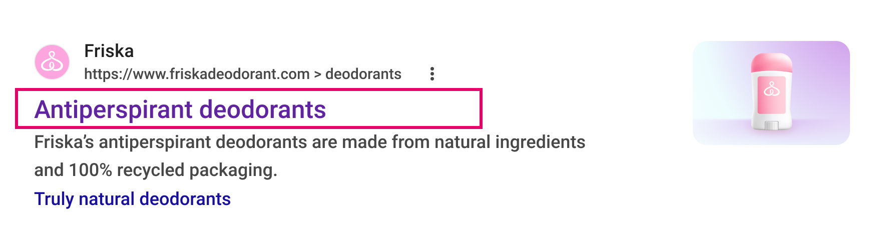

Check the title tags for your product to see if they are:

* Unique
* Descriptive
* Contain relevant keywords

Fill in the table below with your product’s title tags and your assessment of whether they meet the three criteria above.

| ***Title tags*** |  |
| --- | --- |
| ***Tag analysis*** |  |

### Step 3: Meta description

The meta description is typically under the title tag. Review the meta description for relevancy, and inclusion of keywords. For the Friska example, the meta description is *Friska’s antiperspirant deodorants are made from natural ingredients and 100% recycled packaging*. Keywords include organic, clean, deodorant, and recycled.

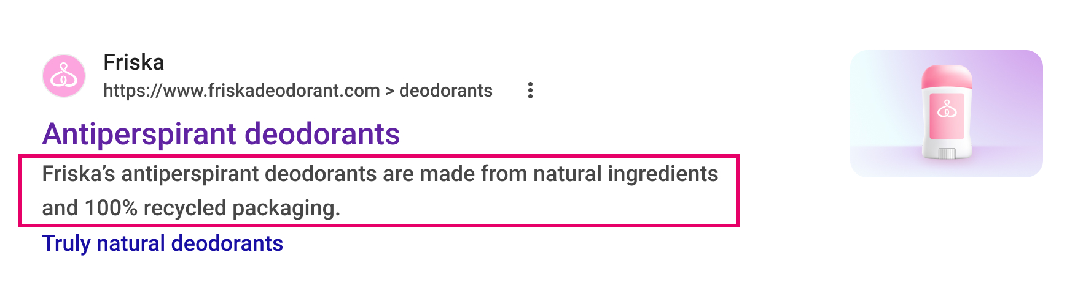

What is its meta description for the product you chose? What are the keywords that are used? Write your answers in the space below.

| ***Meta description*** |  |
| --- | --- |
| ***Keywords*** |  |

### Step 4: Schema markup

The scheme markup gives information about the product category the items should be sold under. It will help with the referencing and optimize the chances to be matched with the potential customers’ queries. In the Friska example the schema markup is *Truly natural deodorants*.

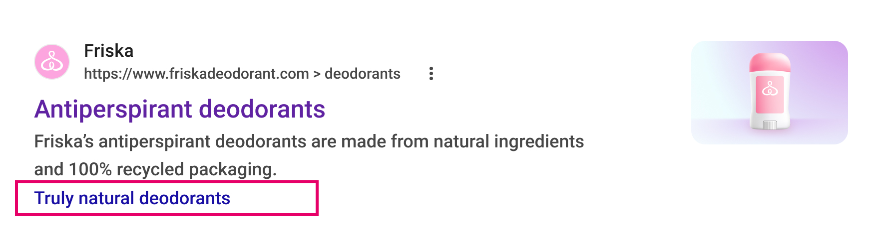

Fill in the schema markup for your product in the table below.

| ***Schema markup*** |  |
| --- | --- |

### Step 5: Content

It’s important to analyze the quality and relevance of the content on each page. Questions to consider include:

* Is each page free of spelling and grammatical errors?
* Are keywords used in a natural way without keyword stuffing?
* Is the content unique?

Analyze your product’s website content and determine its quality and relevance. Write your answers to the three questions above in the space below.

| ***Content analysis*** |  |
| --- | --- |

### Step 6: URL structure

The URL structure is found in the search bar of your search engine browser. The URL structure for the Friska example is *https://www.friskadeodorant.com/us/en/deodorants*

## The URL for the Frika deodorant website.

The URL structure should:

* Be clear and easy to understand.
* Include keywords where appropriate.
* Be free of any long complex string of characters.

Fill in the table below with your product website’s URL structure and your assessment of whether it meets the three criteria above.

| ***URL structure*** |  |
| --- | --- |
| ***URL analysis*** |  |

### Step 7: Images

Analyze each image's alt tags to confirm whether or not they are descriptive and provide context. Visually impaired users rely on alt tags to understand the importance of the image on the web page. To view an alt tag in Chrome, right click on the image and select **Inspect**.

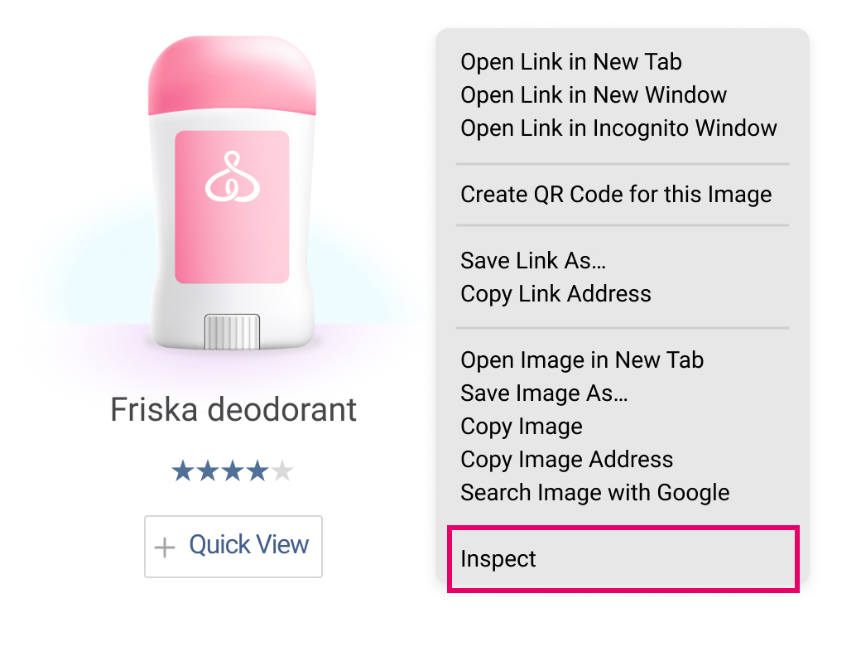

A new page will open on the right side of your browser with the HTML code highlighted for the image you requested the alt tag for. The alt tag for the Friska example is *Friska deodorant.*

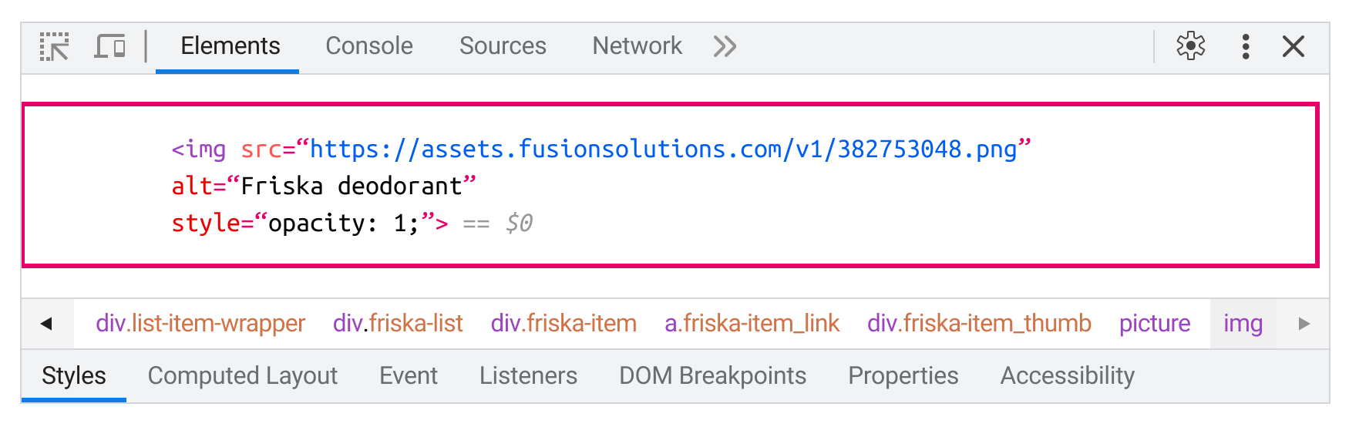

What are some alt tags the company used for the images of your product? Are the alt tags descriptive for the image? Write your answers in the space below.

| ***Alt tags*** |  |
| --- | --- |
| ***Alt tag analysis*** |  |

### Step 8: Mobile optimization

Analyze your product website’s responsiveness and friendliness on your mobile device. Check to make sure that the content displays correctly. You can even rotate your mobile device vertically and horizontally to see how the images and layout of the website change. Trying on different device types will make sure to cover all potential users’ experiences.

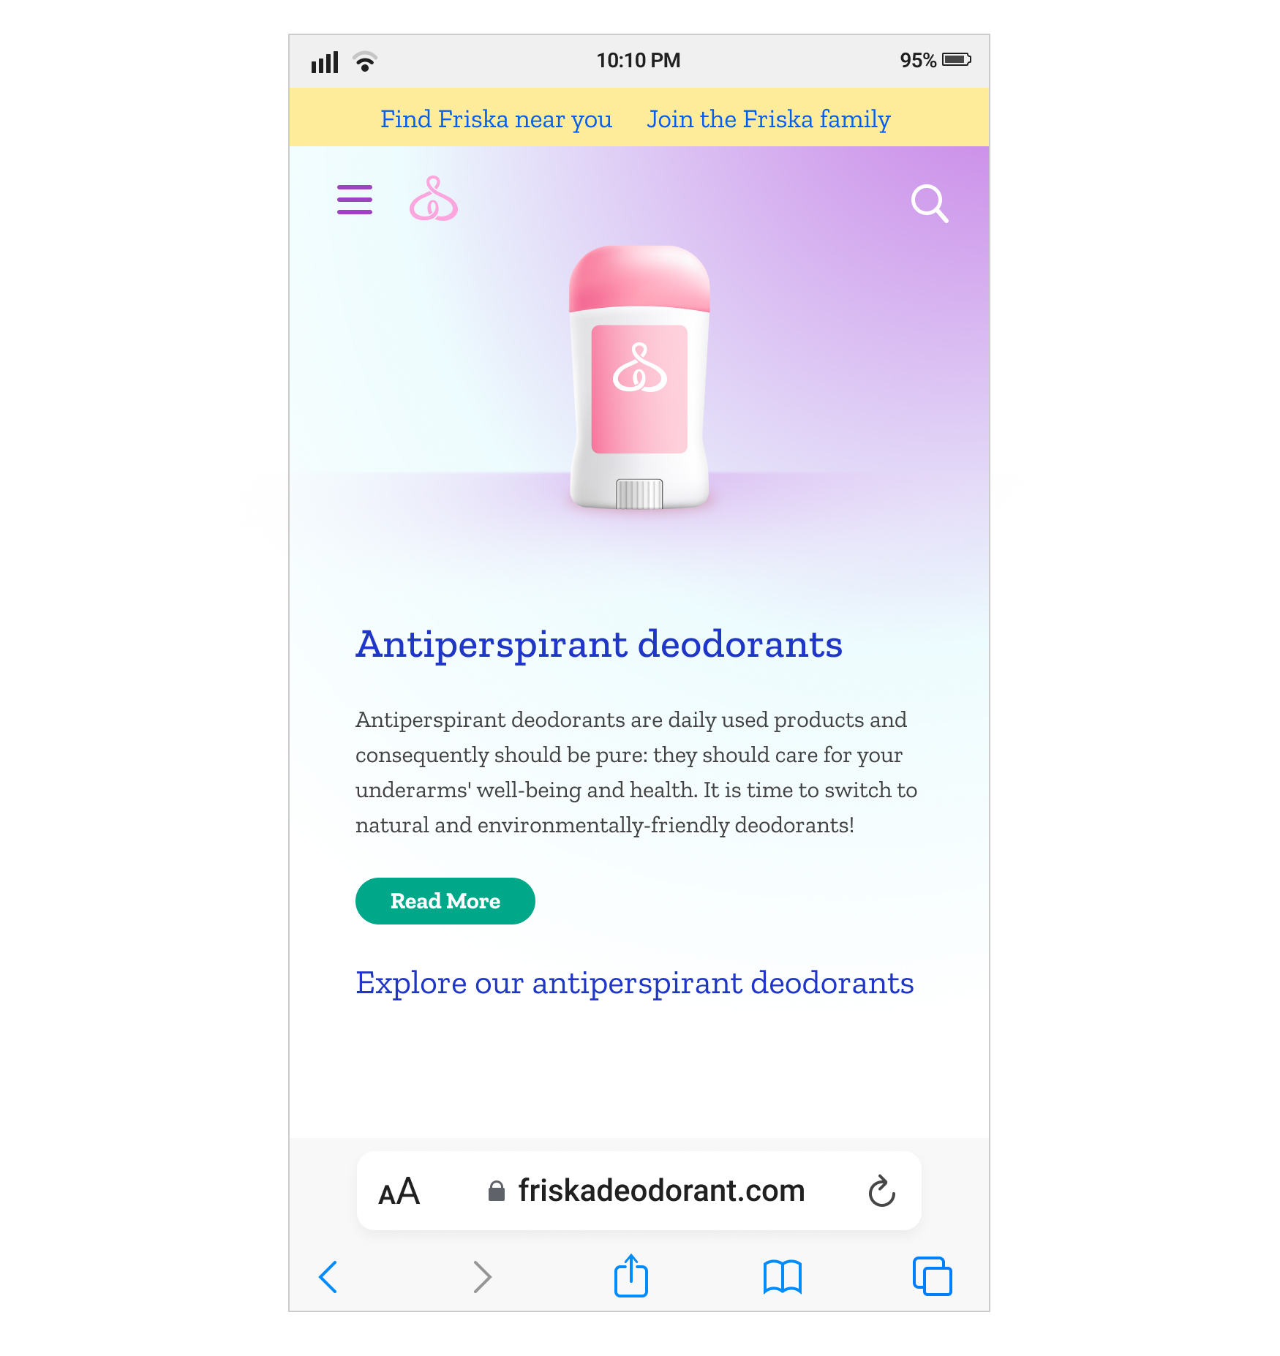

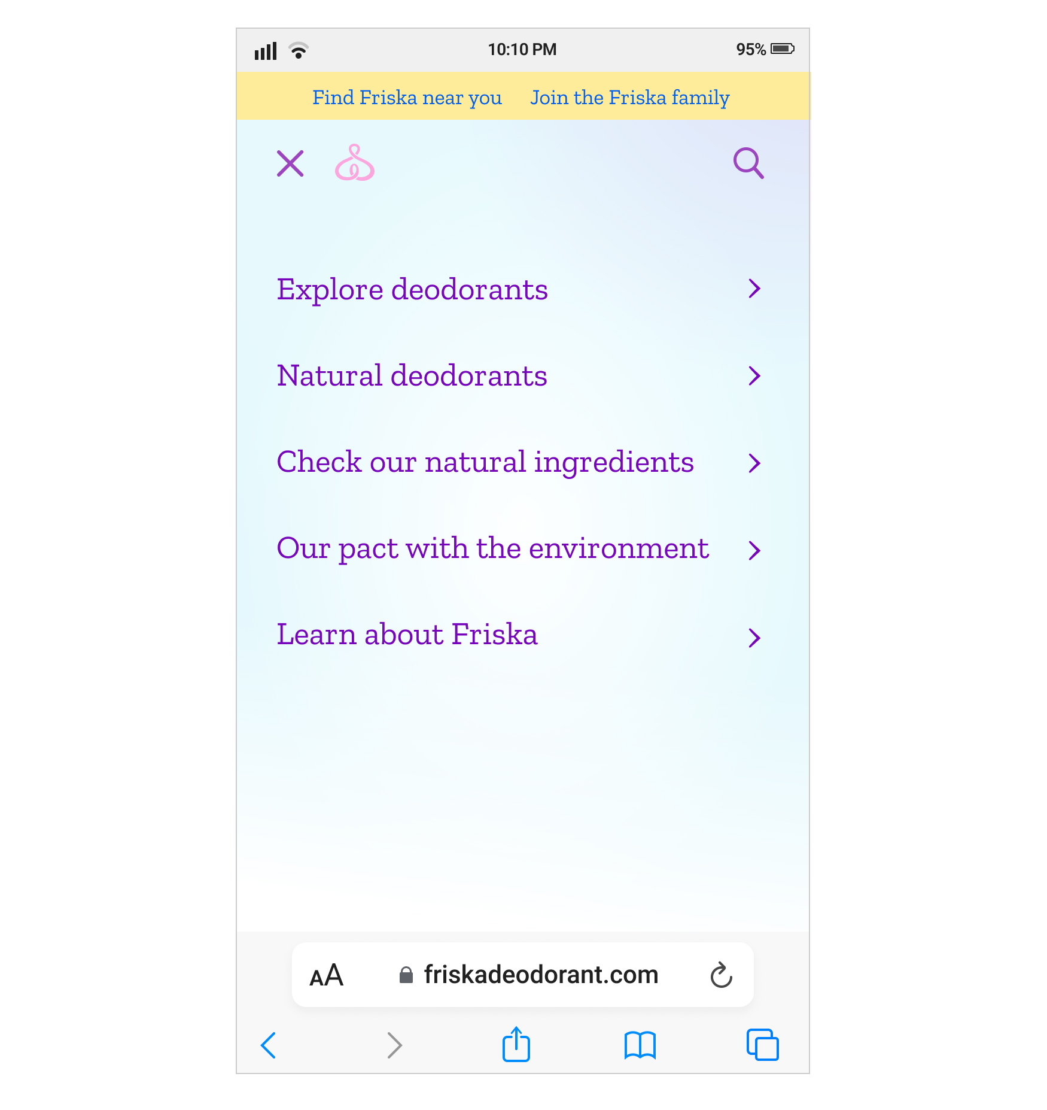

Is your product website’s content mobile-friendly? Why or why not? Write your answer in the space below.

| ***Mobile friendliness*** |  |
| --- | --- |

### Step 9: Internal linking

Analyze and test different internal links within the website to ensure they provide a logical navigation for users. Questions to consider include:

* Are key pages such as the homepage or product pages linked from other pages?
* Do links use descriptive anchor text to make it clear to the user where they lead?
* Is there a logical hierarchy of links, including a top-level navigation leading to subcategories and individual pages?

Under the top-level *Product* link, Friska has a subcategory that includes *deodorants*, *natural collection* and *lotions*. Individual pages under *Deodorants* include; *Browse all deodorants*, *Stick deodorants*, *Natural deodorants*, *Deodorant refills*, and *Lotions.*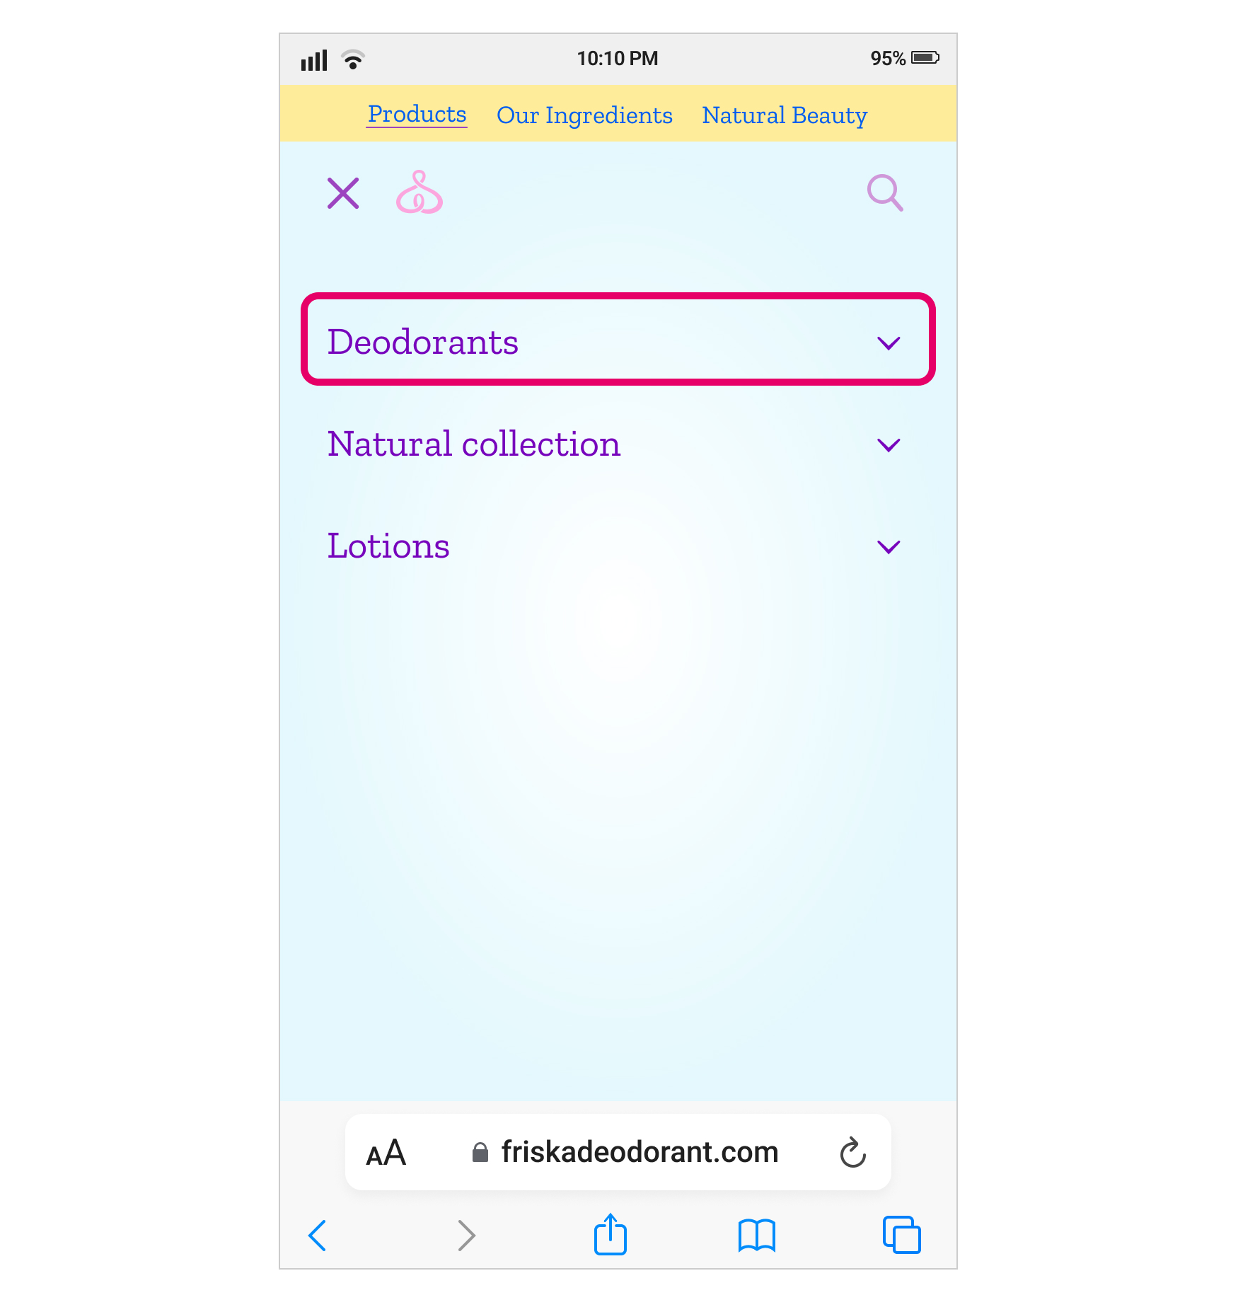

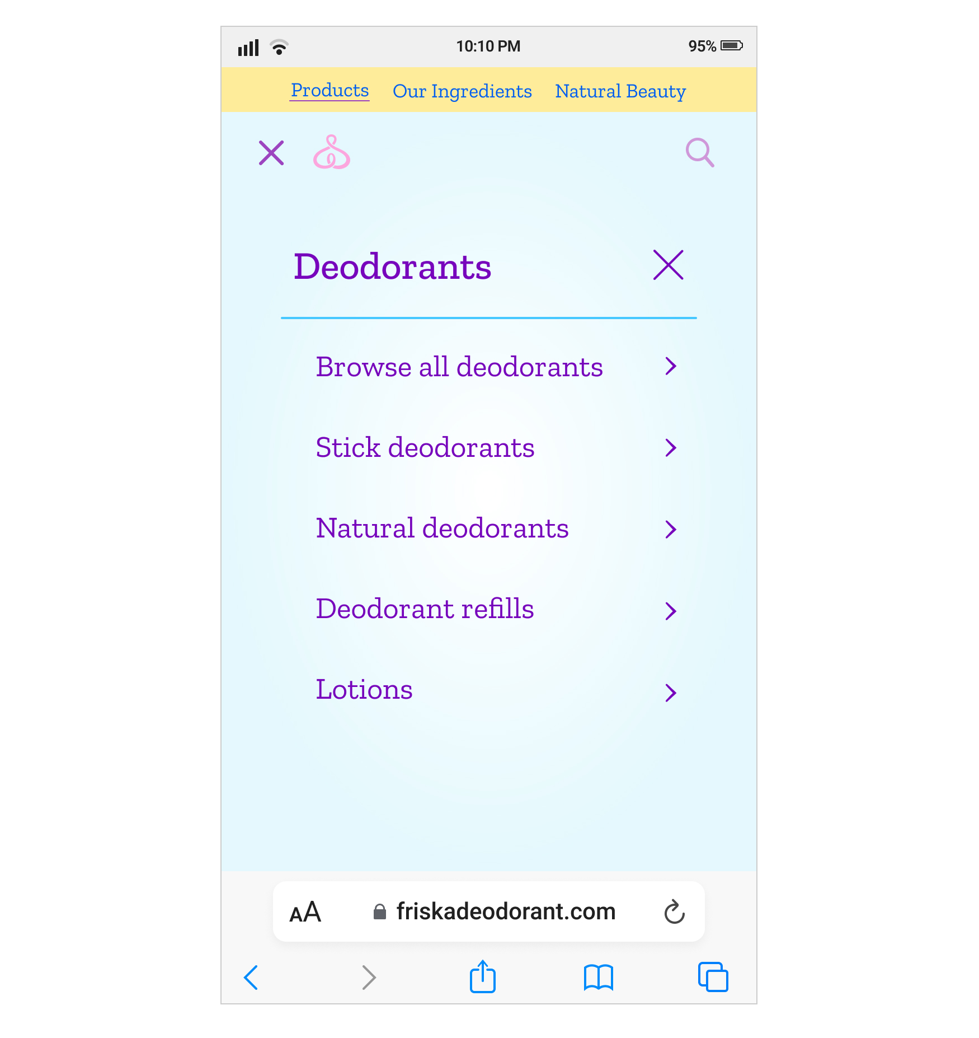

Based on the product you chose, do the internal links provide logical navigation for users? Why or why not? Write your answer in the space below.

| ***Internal linking*** |  |
| --- | --- |

### Step 10: Secure connection

Ensure that the website uses HTTPS for a secure and trustworthy experience for users. The beginning of the URL should contain HTTPS or you might see a lock icon indicating the web page is secure. Otherwise, the website might be blocked on the user’s web browser.



Is your product website’s connection secure? How do you know? Write your answer in the space below.

| ***Secure connection*** |  |
| --- | --- |

### Step 11: User Experience

Evaluate the overall user experience of the web page. The user experience should be positive and welcoming to all users. Questions to consider include:

* Did the web page load within a reasonable amount of time?
* Is it easy to navigate on the site?
* Is the content engaging and relevant to the target audience?
* Is the content easy to read?
* Are the visual design elements visually appealing and consistent with the brand?

How is the user experience for your product’s website? Write your answer in the space below.

| ***User experience*** |  |
| --- | --- |

### 

When you’re ready, go back to [the assignment](https://www.coursera.org/learn/measurement-and-analysis/assignment-submission/qMo49/website-on-page-seo-analysis) to complete the reflective questions.